EXPERIMENT-03

AIM design PDA for input a^nb^n.

PROCEDURE

1. Start the automata
2. Enter the states
3. Connect the respective nodes (states) and self loop.
4. Enter the inputs values in the named nodes .
5. Compile the execution with suitable inputs
6. Stop the executions.

DESIGN INPUT:

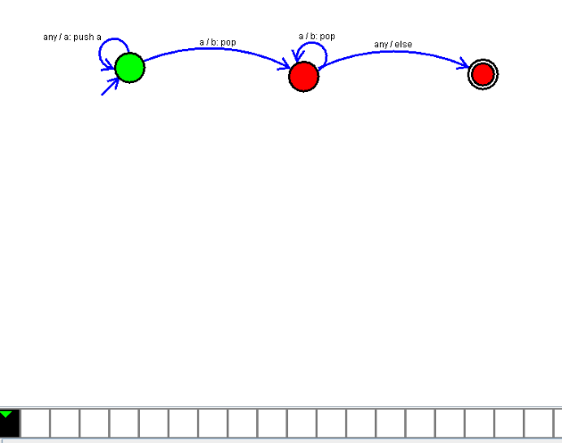

OUTPUT:

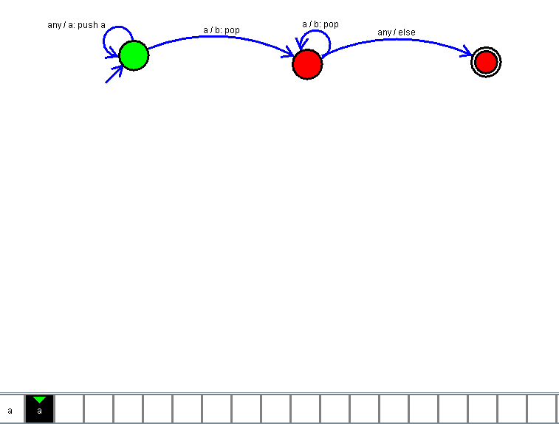

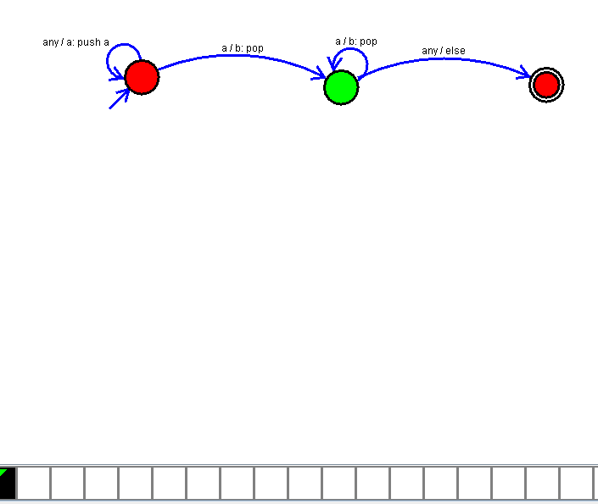

RESULT:

THUS the design of PDA as been executed and implemented successfully.